Fulton Street Reconstruction

City of Waupaca, Wisconsin

Public Involvement Meeting No. 2

Tuesday, June 9, 2026

6:00pm - 7:30pm
Waupaca City Hall
111 South Main Street
Waupaca, WI 54981

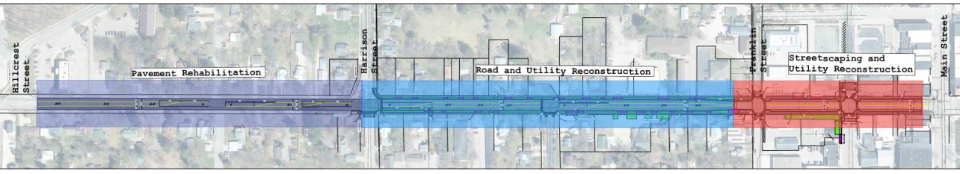
Fulton Street Reconstruction Project Corridor

Welcome to Public Involvement Meeting No. 2 for the reconstruction of Fulton Street in the City of Waupaca. The project extends approximately 3,100 feet along Fulton Street from Hillcrest Drive to Main Street. Representatives from the project team, including the City of Waupaca and Strand Associates, Inc are available to address your questions and concerns. This meeting is an open house format. A brief presentation will be given at 6:00 p.m. followed by an open question and answer session. A subsequent public involvement meeting is tentatively planned for this project in the late Fall of 2025.

Purpose of the Meeting

The purpose of this meeting is to present the current scope of the project, design status and details, answer questions and listen to your comments, concerns, or suggestions. This is an opportunity for you to offer input into the design process. It also provides an opportunity for you to review the proposed design and the potential impacts.

Project Overview

The proposed project can be divided into three distinct segments. Segment 1, located between Main Street and Franklin Street, will include reconstruction of the existing roadway into a downtown streetscaped corridor with concrete pavement, similar to Main Street. Segment 2, located between Franklin Street and Harrison Street, also includes a reconstruction of the roadway with a two-way left turn-lane configuration. Both Segments 1 and 2 involve complete roadway base and underground utility reconstruction, including sanitary sewer, water main, storm sewer, ADA-compliant curb ramps, new pavement, and pavement markings. Segment 3, located between Harrison Street and Hillcrest Drive involves pavement marking replacement at a minimum but may include pavement surface replacement, spot curb and gutter and sidewalk replacement, and new pavement markings.

Anticipated Project Schedule

Alternative Analysis & First Public Involvement Meeting (Completed) | July 2025
30 Percent Design Completion & Design Review with City Staff (Completed) | January 2026
60 Percent Design Completion & Second Public Involvement Meeting | June 2026
Final Design | July-October 2026
Solicitation of Construction Bids | Nov.-Dec. 2026
Anticipated Construction Commencement | Spring 2027
Anticipated Construction Completion | Fall 2027

Public Comments

We encourage you to share your comments and concerns about the project. A comment sheet is included with this handout for your convenience. Please submit your comments in the comment box at tonight’s meeting or mail any comments before July 1, 2026. If mailing your comments, please remember to fold the comment sheet on the lines shown, tape it shut and place a stamp on it.

Project Contacts

Brandon Herbert, P.E.  Consultant Project Manager  Strand Associates, Inc.®  910 West Wingra Drive  Madison, WI 53715  Phone: (608) 251-4843  E-Mail: Brandon.herbert@strand.com | Tyler Wallin, P.E.  Project Engineer  Strand Associates, Inc.®  910 West Wingra Drive  Madison, WI 53715  Phone: (608) 251-4843  E-Mail: tyler.wallin@strand.com

City Contacts
Justin Berrens  Interim City Administrator/Director of Public Works  City of Waupaca  111 S Main Street  Waupaca, WI 54981  Phone: (715) 258-4411  E-Mail: justin.berrens@waupacawi.gov | Nate Smith  Street Superintendent  City of Waupaca  111 S Main Street  Waupaca, WI 54981  Phone: (715) 258-4411  E-Mail: justin.berrens@waupacawi.gov

